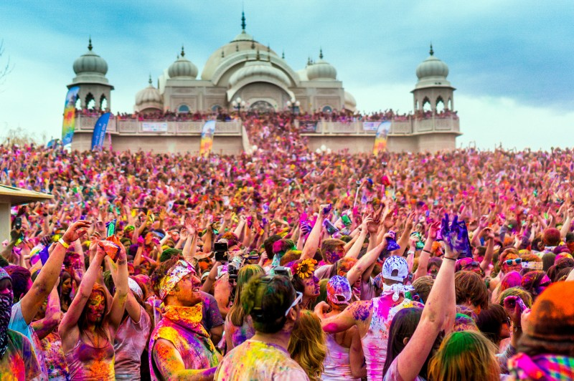

**WORLD FESTIVALS**

Table of Contents

Acknowledgement 3

SYNOPSIS 4

ANALYSIS 5

DFD Diagram 6

LAYOUT DESIGN 7

FLOW CHART 11

PROCESS DIAGRAM 12

Screen Shot 13

Home 13

Contact Us 14

About Us 15

Queries link 16

Gallery 17

Site Map 18

Order Form 19

User Manual 20

Introduction 20

Home page 21

News page 23

Contact us page 26

About Us page 27

Queries link page 29

Gallery page 31

Category page 34

Site Map page 37

Order page 39

DEVELOPER’S GUIDE 40

HTML 40

CSS CODE 71

# Acknowledgement

The success and final outcome of this project required a lot of guidance and assistance from our lecturer Mr. Kenneth. All that we have done is only due to his supervision and assistance and we would not forget to thank him. We respect him for providing us an opportunity to do the project work [World Festivals] and giving us all support and guidance which made us complete the project on time.

We are extremely thankful to him for providing such a nice support and guidance, although he had busy schedule attending other class. He guided us all along, till the completion of our project work by providing all the necessary information for developing a good website.

We would not forget to remember our team members who worked and spent a lot of time on the project so that we would finish on time. They also gained a lot of experience like how to work in a group and making a better website.

Team members: Paul Kanyike

James Ngugi

Purity

Abdul

# SYNOPSIS

Work Division

We first divide the work amongst ourselves. Each person was making a page for the website. We had to research for the festivals in the internet for all the four continent we choose to work on, downloaded photos and pdfs. We made the header and the footer using the same css, html and photos making our work uniform and attractive. The rest we divided amongst ourselves making the header and footer uniform. After we all worked on our assigned pages we linked all to each other to make a complete website. We worked on the JavaScript and responsiveness of the website at the end.

Documentation

After the completion of the website we had to work on the documentation. Dividing the work seemed to work for us, so we allocated work for each team member to work on the various contents of the documentation for us to have a complete document of the work done for the website. After that we joined all the information to make a complete document. And on time we finished the project due to some of the challenges we went through.

# ANALYSIS

The website advertises most of the festival in the four continents and which are widely practiced in the countries specified .People treasurer what they do and make them happy and one of them are festival they celebrate. The website keeps the people update concerning the festivals both the indigenous of the festivals and interested parties from all over the world.

They are specific months when the festivals are held in certain countries and we try to inform the people who view the website how they can attend the festivals so we book plane tickets and lounges for the interested persons. This is due to our connection with most of the Airports in the Most of the countries and this makes it easier to arrange flights to our customers, we also have some of the lounges owned by the organization in those countries festivals happen.

Making the project needed a lot of dedication both one’s time and energy. We actually divide the work amongst ourselves and later on we compiled our work to come out with a quality product for our target users. The team cooperation and commitment led to successful completion of the website.

The website accommodates new ideas with the help of the Query link which the users can ask questions and get reply either by sending us an email or chatting and writing comments. We also invite new members all over the world by creating accounts so they can access more information about the World festival Organization. The website allows users to talk to the Heads of the organization directly via email.

# DFD Diagram

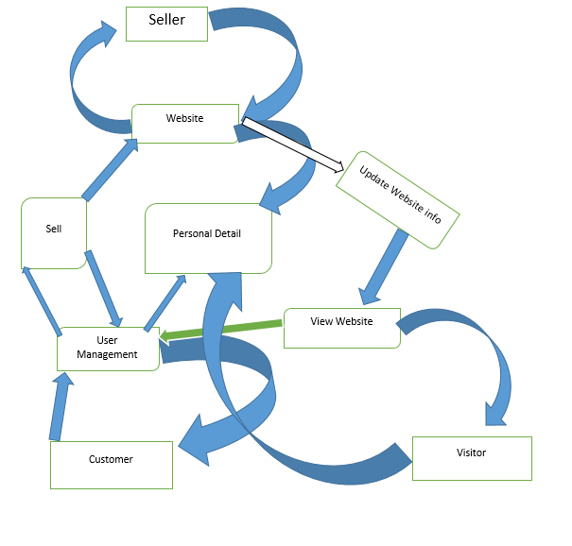

# LAYOUT DESIGN

HOME

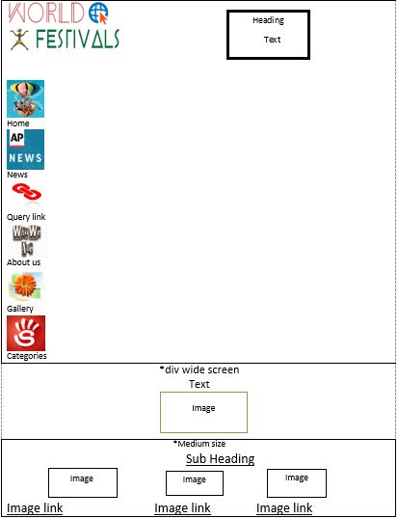

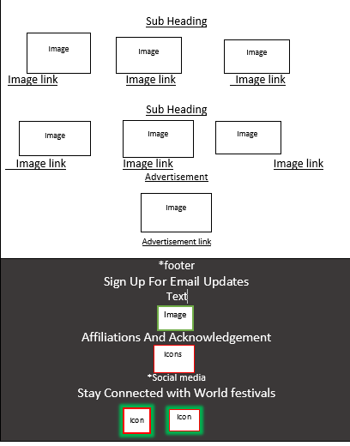

CATEGORY

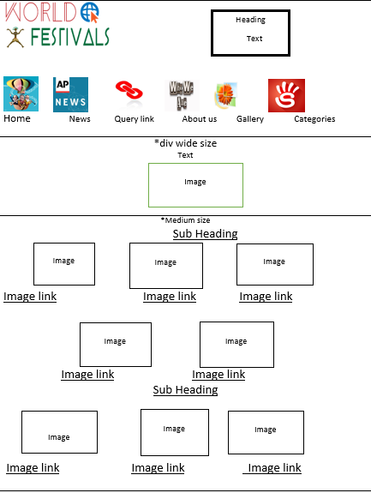

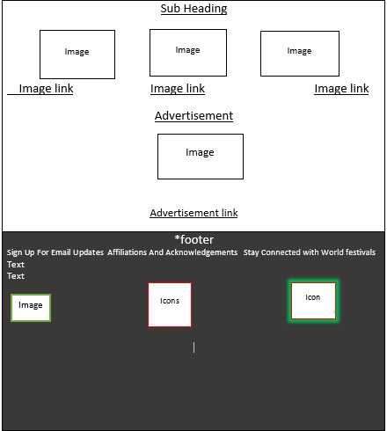

# FLOW CHART

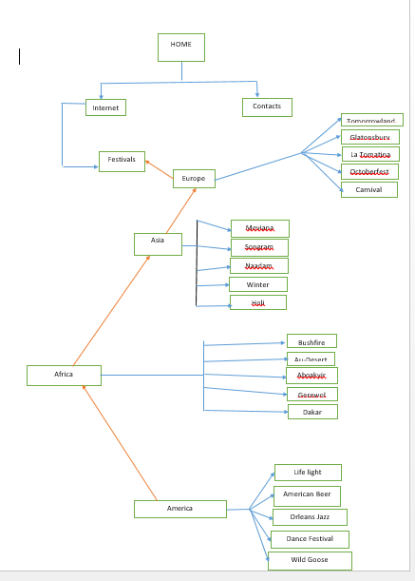

# PROCESS DIAGRAM

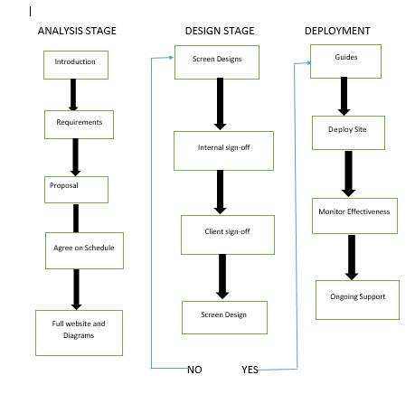

# Screen Shot

## Home

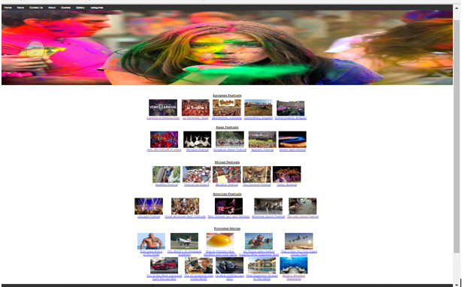

## Contact Us

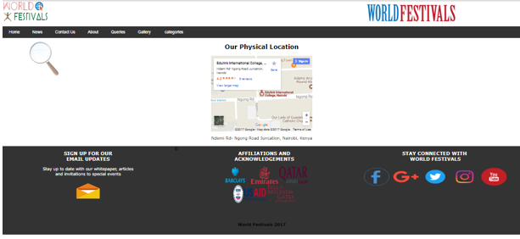

## About Us

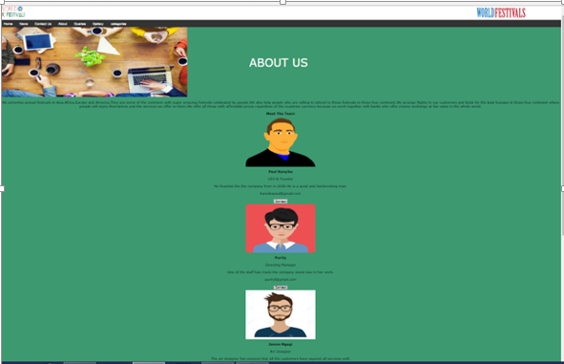

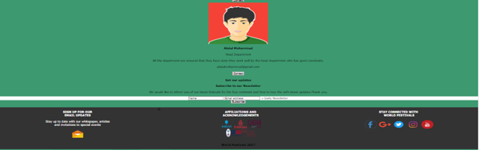

## Queries link

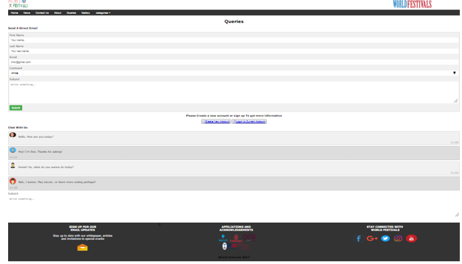

## Gallery

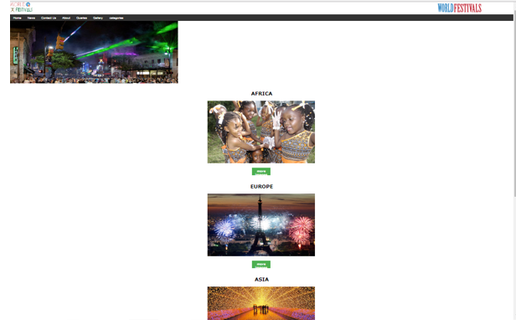

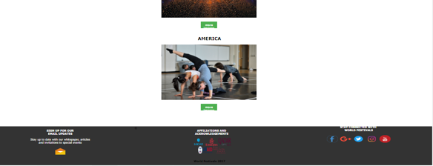

## Site Map

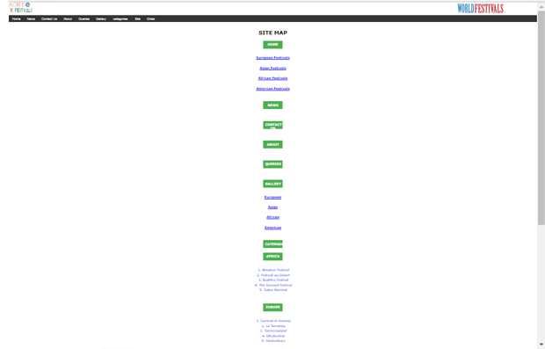

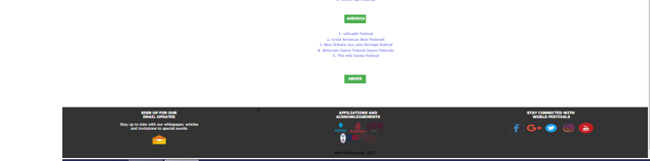

## Order Form

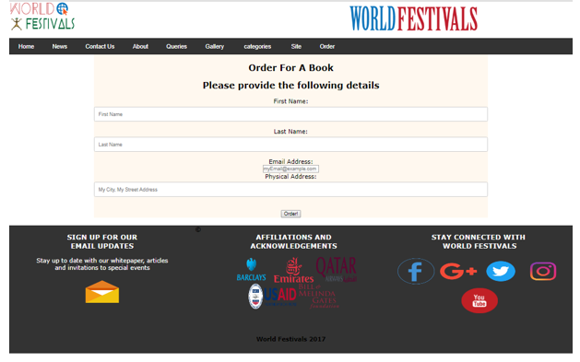

# User Manual

## Introduction

This manual is produce to provide information about the World Festival Website which is created to provide information about the world festivals, not only the information but also the images that shows you what happens during the festivals.

## Home page

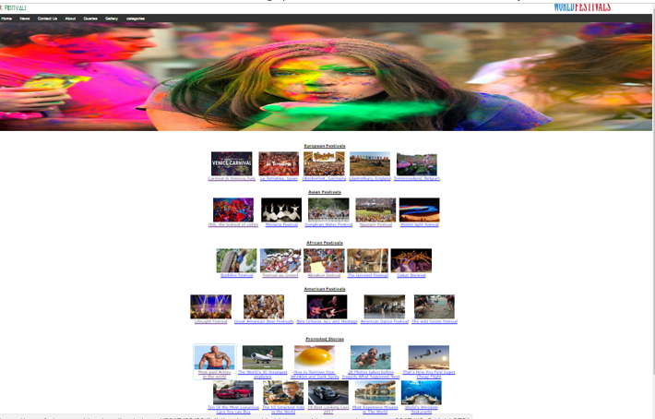

The home page shows some continent, images and links. When you click on the links it opens to show you some images and information about the link you clicked on.

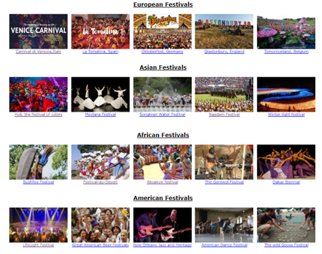

The home page also shows some images and links of the promoted stories and the footer, but the footer appears in every page. The footer gives information on how to get connected and get the updates.

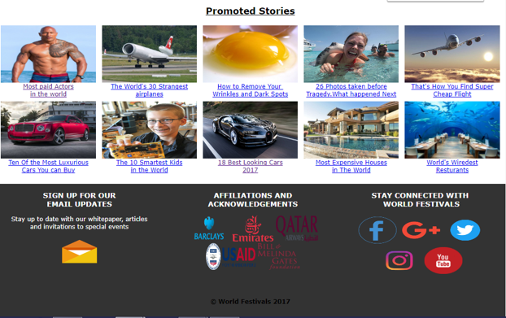

## News page

The news page shows images of different festivals with their links, when you click on the links their open in a new page.

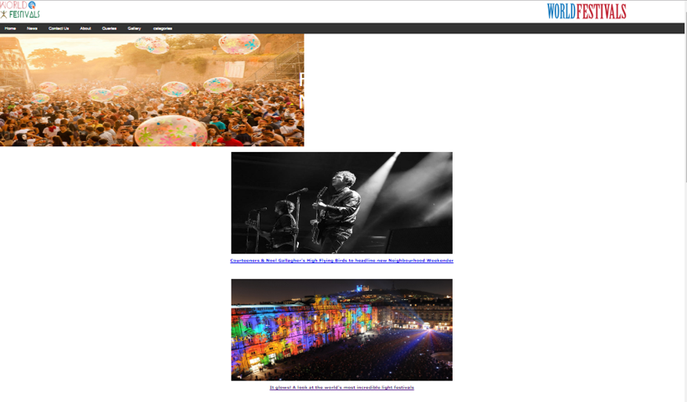

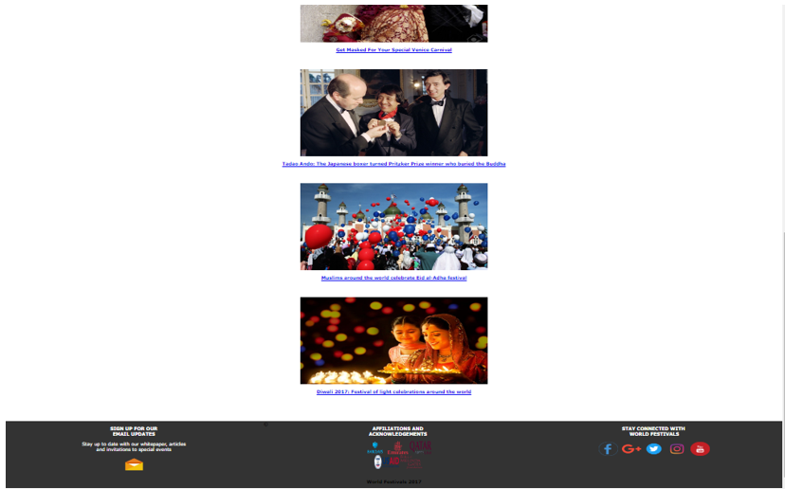

The page has a top image that has a link on top of it, the link takes you to the gallery of the

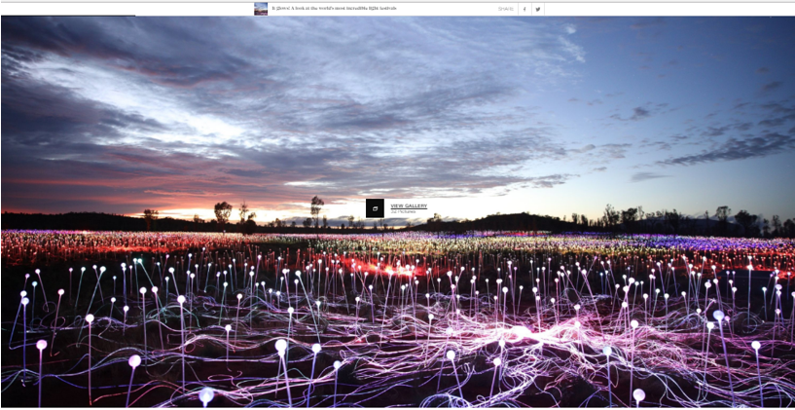

Festival you clicked on to see the next image you need to click on the arrow, apart from the image you will also see some information about the festival you clicked on.

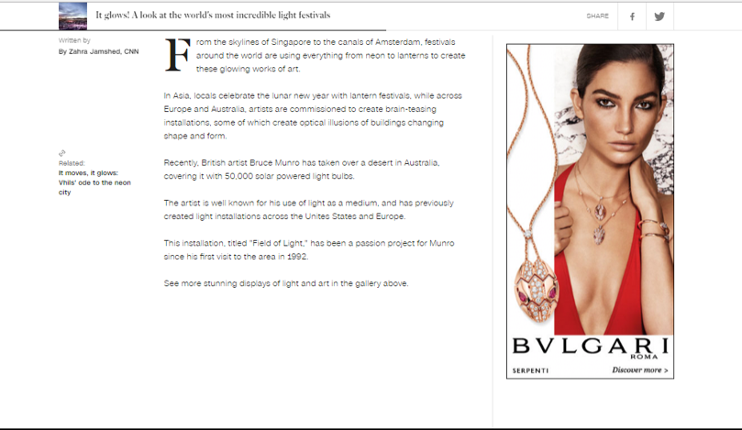

## Contact us page

The contact us page shows a map that shows you where we are located at and as l mentioned early the footer appears in every page

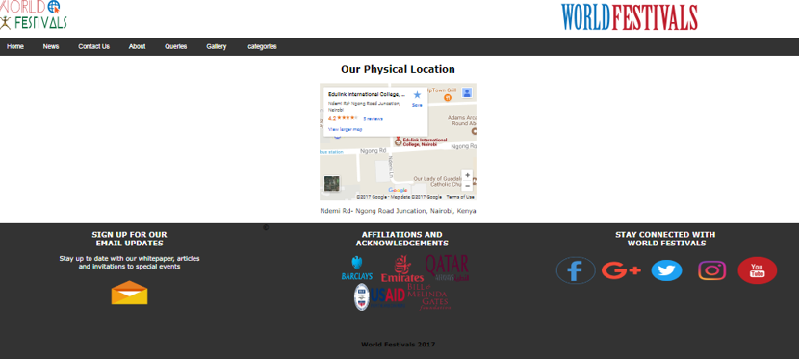

## About Us page

About page tells you what we do and what we offer to our customers .It also shows you the members of the websites and their email.The page also tells you how you can get our updates and subscribe to our newsletter

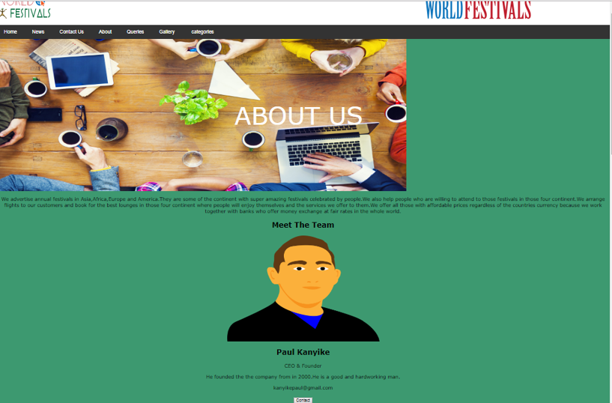

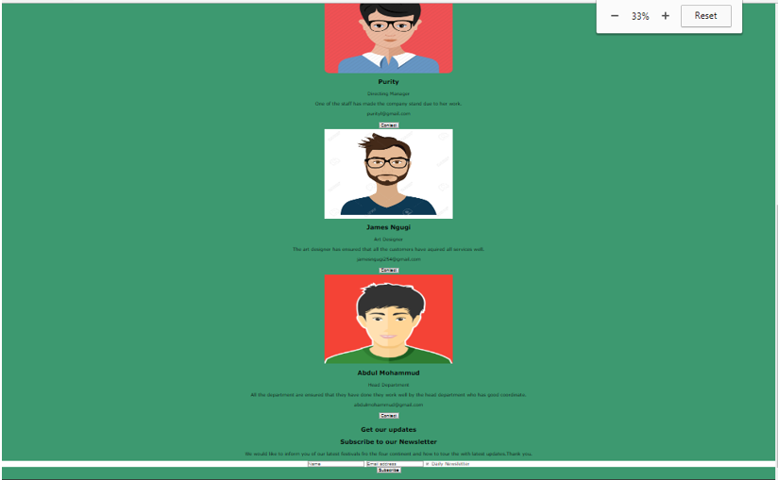



## Queries link page

This page gives you a chance to ask any question about the website or the festivals through a direct email. And to do that you must have an account or you can create one.

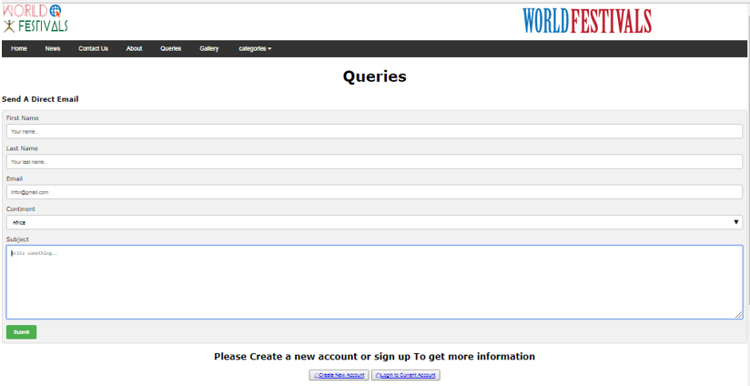

You can also chat with us.

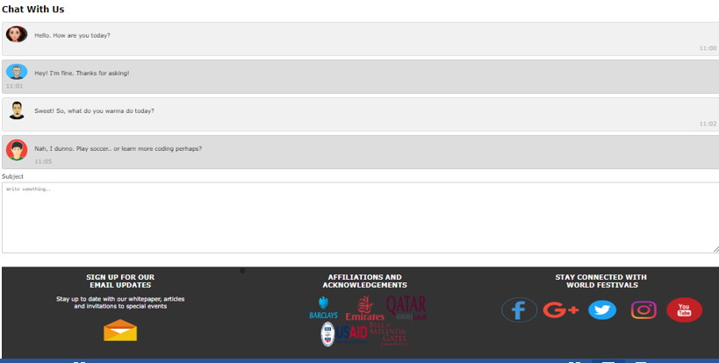

## Gallery page

This page shows you the continent name,image and a link.

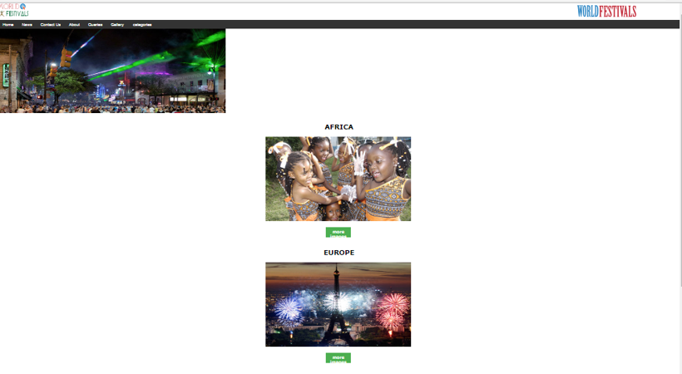

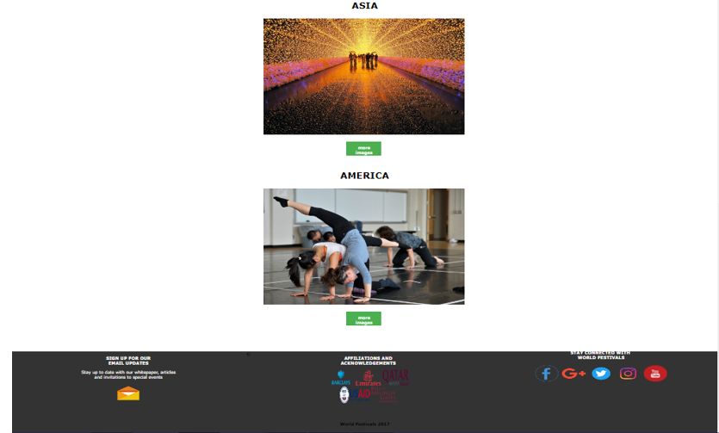

The link opens and shows you images of the continent you clicked on.

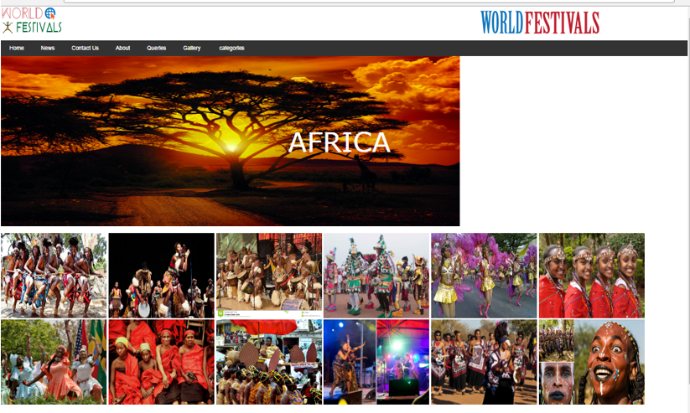



## Category page

When you click on category page a dropdown menu appears, it shows you the three continents. When you click on one of the continent you will see the top five festivals in that continent. To get more information about the festival you can click on the link provided after every festival

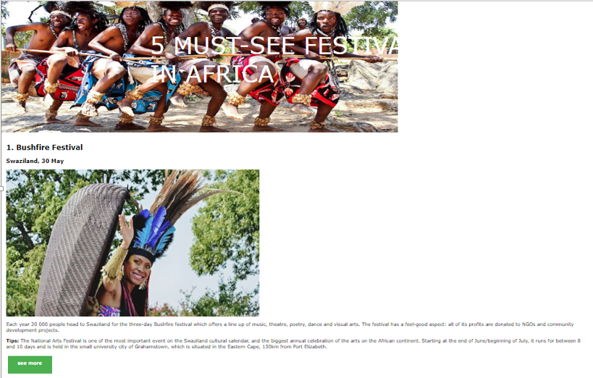

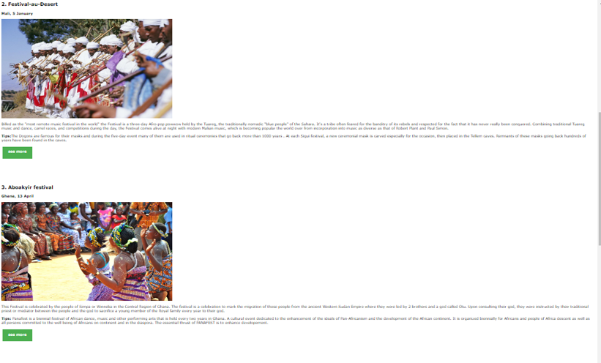

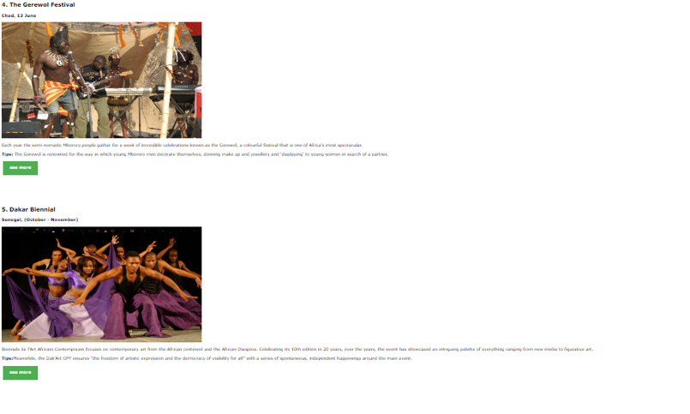



## Site Map page

It gives you a brief summary about the website

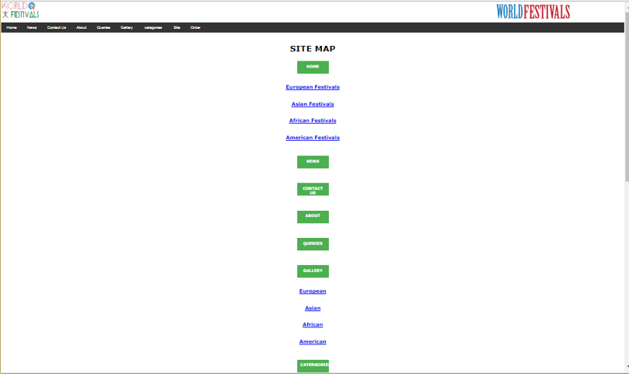

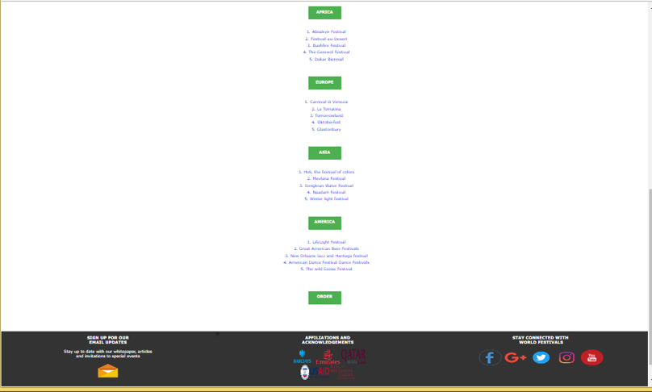

## Order page

This page gives you a chance to order a book.To order, you need to provided us with some details.

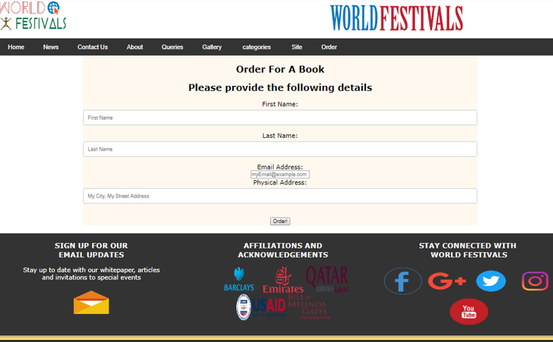

# DEVELOPER’S GUIDE

## HTML

HOME PAGE

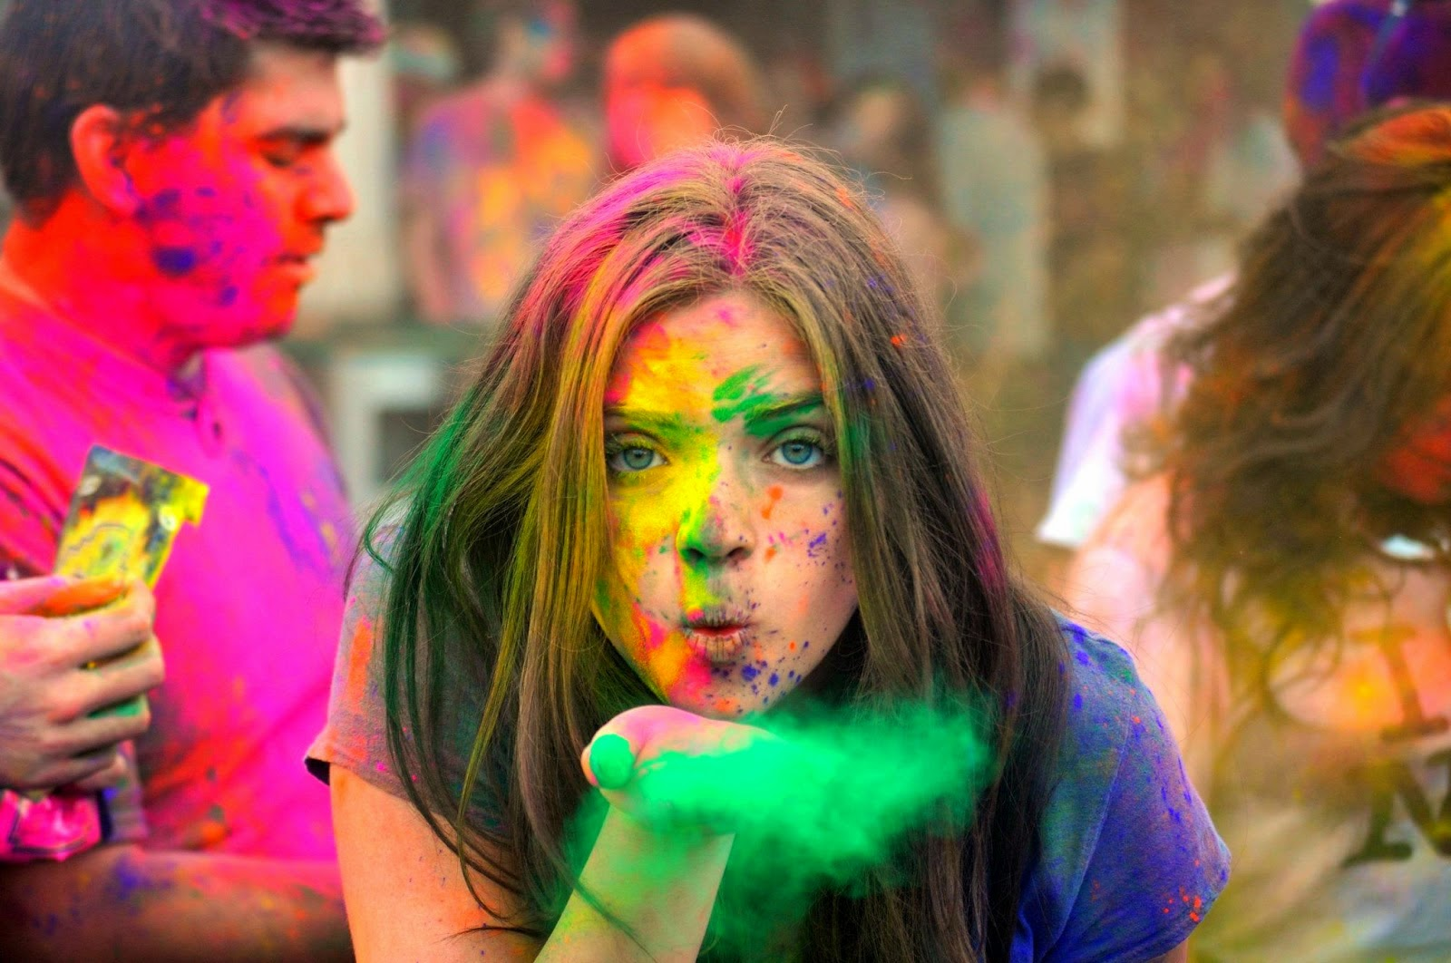

<!DOCTYPE html PUBLIC "-//W3C//DTD XHTML 1.0 Transitional//EN" "http://www.w3.org/TR/xhtml1/DTD/xhtml1-transitional.dtd">

<html xmlns="http://www.w3.org/1999/xhtml">

<head>

<meta name="viewport" content="width=device-width, initial-scale=1.0">

<meta http-equiv="Content-Type" content="text/html; charset=utf-8" />

<title> World Festivals</title>

<link href="../css/index.css" rel="stylesheet" type="text/css" />

<script src="../scripts/index.js"></script>

<img src="image.jpg"

data-src-600px="image-600px.jpg"

data-src-800px="image-800px.jpg"

alt="">

</head>

<header>

<img class="logo" src="../photos/festival-1.png" width="180" height="90" />

<img class="logo2" src="../photos/Untitled-2.png" width="360" height="90" alt="logo heading" />

</header>

<body >

<div class="navbar">

<a href="#index.html">Home</a>

<a href="News.html">News</a>

<a href="co.html">Contact Us</a>

<a href="About us.html">About</a>

<a href="Contact us.html">Queries</a>

<a href="Gallery - Copy.html">Gallery</a>

<div class="dropdown">

<button class="dropbtn">categories

<i class="fa fa-caret-down"></i>

</button>

<div class="dropdown-content">

<a href="Africa.html">Africa</a>

<a href="Europe.html">Europe</a>

<a href="Asia.html">Asia</a>

<a href="America.html">America</a>

</div>

</div>

</div>

<div>

<img src="../photos/backlgrnd.jpg" width="100%" height="667" alt="holi festival" /> </div>

<br><br>

<u><center><h2>European Festivals</h2></center></u>

<center><a href="Carnival di Venezia.html">

<img src="../photos/europe/maxresdefault.jpg" width="250" height="150" alt="itay" />

<div class="desc">Carnival di Venezia,Italy</div>

</a>

<a href="Tomatina.html">

<img src="../photos/europe/La-Tomatina_tablet_banner.jpg" width="250" height="150" alt="spain" />

<div class="desc">La Tomatina, Spain</div>

</a>

<a href="Octoberfest.html">

<img src="../photos/europe/oktoberfest-beerfest-of-germany.jpg" width="250" height="150" alt="germany" />

<div class="desc">Oktoberfest, Germany</div>

</a>

<a href="Glastonbury.html">

<img src="../photos/europe/102395766_10.jpg" width="250" height="150" alt="england" />

<div class="desc">Glastonbury, England</div>

</a>

<a href="Tomorrow.html">

<img src="../photos/europe/3aaf09b2e2f67fdba2964453318e285e.jpg" width="250" height="150" alt="belgium" />

<div class="desc">Tomorrowland, Belgium</div>

</a>

<br>

</div>

<br>

<u><center><h2>Asian Festivals</h2></center></u>

<center><a href="holi, the festival of colors.html">

<img src="../photos/holi-the-festival-of-colors-india-109420836-58e011443df78c51624c663b.jpg" width="250" height="150" alt="holi festival" />

<div class="desc">Holi, the festival of colors</div>

</a>

<a href="mevlana festival.html">

<img src="../photos/mevlana-festival.jpg" alt="mevlana festival" width="250" height="150" />

<div class="desc">Mevlana Festival</div>

</a>

<a href="Songkran Water Festival.html">

<img src="../photos/water-fight-650x433.jpg" width="250" height="150" alt="songkran water festival" />

<div class="desc">Songkran Water Festival</div>

</a>

<a href="Naadam festival.html">

<img src="../photos/Naadam-Festival-04.jpg" width="250" height="150" alt="naadam festival" />

<div class="desc">Naadam Festival</div>

</a>

<a href="winter light festival.html">

<img src="../photos/3206293638_a8691fd4f1_b.jpg" width="250" height="150" alt="Japan, (November – March)" />

<div class="desc">Winter light festival</div>

</a>

<br>

</div>

<br>

<div>

<br>

<u><center><h2>African Festivals</h2></center></u>

<center><a href="Bushfire.html">

<img src="../photos/africa images/look.jpg" width="250" height="150" alt="holi festival" />

<div class="desc">Bushfire Festival</div>

</a>

<a href="Festival Au desert.html">

<img src="../photos/africa images/79389750-56a375483df78cf7727d7595.jpg" alt="mevlana festival" width="250" height="150" />

<div class="desc">Festival-au-Desert</div>

</a>

<a href="Aboakyir festival.html">

<img src="../photos/africa images/Aboakyri photos/ghana-women-dance.jpg" width="250" height="150" alt="songkran water festival" />

<div class="desc">Aboakyir festival</div>

</a>

<a href="Gerewol Festival.html">

<img src="../photos/africa images/Lake_of_Stars_firesika_CC.jpg" width="250" height="150" alt="naadam festival" />

<div class="desc"> The Gerewol Festival</div>

</a>

<a href="Dakar Biennial.html">

<img src="../photos/africa images/14-05-2013-mophato-dance-theatre-to-performance-at-national-arts-festival-1368535856_image_main2769.jpg" width="250" height="150" alt="Japan, (November – March)" />

<div class="desc">Dakar Biennial</div>

</a>

<br>

</div>

<div>

<br>

<u><center><h2>American Festivals</h2></center></u>

<center><a href="Lifelight festival.html">

<img src="../american photos/life.png" width="250" height="150" alt="holi festival" />

<div class="desc">LifeLight Festival</div>

</a>

<a href="Great American Beer Festivals(GABF).html">

<img src="../american photos/0000007_4YH7YL4.png" alt="mevlana festival" width="250" height="150" />

<div class="desc">Great American Beer Festivals</div>

</a>

<a href="New Orleans Jazz and Heritage festival.html">

<img src="../american photos/maxresdefault.jpg" width="250" height="150" alt="songkran water festival" />

<div class="desc">New Orleans Jazz and Heritage</div>

</a>

<a href="American Dance Festival.html">

<img src="../american photos/american dance.jpg" width="250" height="150" alt="naadam festival" />

<div class="desc"> American Dance Festival </div>

</a>

<a href="The wild Goose Festival.html">

<img src="../american photos/wild-goose-starfish-mandala.jpg" width="250" height="150" alt="Japan, (November – March)" />

<div class="desc">The wild Goose Festival</div>

</a>

<br>

</div>

<br><br>

<u><center><h2>Promoted Stories</h2></center></u>

<center><a href="https://www.forbes.com/sites/natalierobehmed/2017/08/22/full-list-the-worlds-highest-paid-actors-and-actresses-2017/#3a0d4cbb3751">

<img src="../photos/europe/Dwayne-Johnson-Hottest-Movie-Pictures.jpg" width="250" height="150" />

<div class="desc">Most paid Actors<br /> in the world<br /> </div>

</a>

<a href="http://knowledgedish.com/the-strangest-airplanes/?utm_source=16285&utm_medium=revcontent&utm_term=editorial_news&utm_content=2504097&utm_campaign=349684&view=list&layout=revcontent">

<img src="../photos/Plane_Turbine.png" alt="mevlana festival" width="250" height="150" />

<div class="desc">The World's 30 Strangest<br /> airplanes<br /> </div>

</a>

<a href="http://www.beautytrendsoftheworld.com/kesERmEnYnpkg/index.php?cid=MTQwMDQ4MjcwNCMxMDAwMDA1NTY3I3dRR0swOU9GME9KSVVPTDlIMjI5OTQ4UCNLRU5ZQSNOYWlyb2JpIyMjIyMjIw==">

<img src="../photos/1200px-Raw_egg.jpg" width="250" height="150" alt="songkran water festival" />

<div class="desc">How to Remove Your <br />Wrinkles and Dark Spots<br /> </div>

</a>

<a href="http://buzzavoo.com/unbelievable-photos-taken-seconds-before-tragedy-struck/?utm_source=16285&utm_medium=revcontent&utm_term=editorial_news&utm_content=2504122&utm_campaign=349693&view=list&layout=revcontent">

<img src="../photos/1-8.jpg" width="250" height="150" alt="naadam festival" />

<div class="desc">26 Photos taken before<br />Tragedy.What happened Next</div>

</a>

<a href="https://www.save70.com/?utm_source=clicktraffic_rev_forbes&utm_medium=16285">

<img src="../photos/flight-759.jpg" width="250" height="150" alt="Japan, (November – March)" />

<div class="desc">That's How You Find Super<br />Cheap Flight</div>

</a>

<center><a href="http://www.roadandtrack.com/car-culture/buying-maintenance/g6830/best-luxury-cars-brands/">

<img src="../photos/2-800-oemexteriorfront1300-76893.jpg" width="250" height="150" alt="holi festival" />

<div class="desc">Ten Of the Most Luxurious<br /> Cars You can Buy</div>

</a>

<a href="http://www.businessinsider.com/the-10-smartest-kids-in-the-world-2013-4?IR=T">

<img src="../photos/smartest-kids-girls-boys-5.jpg" alt="mevlana festival" width="250" height="150" />

<div class="desc">The 10 Smartest Kids<br />in the World</div>

</a>

<a href="http://www.carophile.org/18-best-looking-cars-buy-2017/?utm_source=taboola&utm_medium=referral">

<img src="../photos/2017-Bugatti-Chiron-Sports-Car.jpg" width="250" height="150" alt="songkran water festival" />

<div class="desc">18 Best Looking Cars<br />2017</div>

</a>

<a href="https://www.cbsnews.com/media/10-of-the-worlds-most-expensive-homes/">

<img src="../photos/contemporary-exterior-of-home-with-stucco-i_g-IS-16xomt02np9wd-jxZ9M.jpg" width="250" height="150" alt="naadam festival" />

<div class="desc">Most Expensive Houses<br />in The World</div>

</a>

<a href="https://www.thrillist.com/travel/nation/the-world-s-10-weirdest-restaurants-thrillist-nation">

<img src="../photos/01_Restaurants-with-the-Weirdest-Dining-Experiences-in-the-World_ithaa-congradhotels-380x254.jpg" width="250" height="150" alt="Japan, (November – March)" />

<div class="desc">World's Wiredest<br />Resturants</div>

</a>

</body>

<footer>

<div class="footer1">

<center><h3>SIGN UP FOR OUR<br /> EMAIL

UPDATES</h3></center>

<center><p>Stay up to date with our whitepaper, articles<br />

and invitations to special events</p></center>

<center><a href="https://accounts.google.com/ServiceLogin/signinchooser?service=mail&passive=true&rm=false&continue=https%3A%2F%2Fmail.google.com%2Fmail%2F&ss=1&scc=1&ltmpl=default&ltmplcache=2&emr=1&osid=1&flowName=GlifWebSignIn&flowEntry=ServiceLogin">

<img src="../photos/icons/email.png" width="100" height="70" /></a></center>

</div>

<div class="footer3">

<center>

<h3>STAY CONNECTED WITH <BR />

WORLD FESTIVALS</h3>

<center><a href="https://www.facebook.com/">

<img src="../photos/icons/Facebook-HD.png" width="100" height="70" alt="facebook" />

</a>

<a href="https://plus.google.com/discover">

<img src="../photos/icons/seeicons__5783504dc2e00.png" width="100" height="70" />

</a>

<a href="https://twitter.com/?lang=en">

<img src="../photos/icons/twitter_PNG28.png" width="100" height="70" />

</a>

<a href="https://www.instagram.com/?hl=en">

<img src="../photos/icons/instagram_PNG3.png" width="100" height="70" />

</a>

<a href="https://www.youtube.com/">

<img src="../photos/icons/YouTube.png" width="100" height="70" />

</a>

</center>

</div>

<div class="footer2">

<center>

<h3>AFFILIATIONS AND<BR /> ACKNOWLEDGEMENTS</h3>

<img src="../photos/icons/Barclays-Logo.png" width="110" height="70" />

<img src="../photos/icons/500px-Emirates_logo.svg.png" width="110" height="70" />

<img src="../photos/icons/Qatar_Airways_Logo.png" width="110" height="70" /><br />

<img src="../photos/icons/USAID-Identity.svg.png" width="130" height="70" />

<img src="../photos/icons/gates-logo-bda5cc0866e8e37eccab4ac502b916c1.png" width="110" height="70" />

</div>

<center><h4> &copy; World Festivals 2017</h4></center>

</footer>

</html>

NEWS PAGE



<!DOCTYPE html PUBLIC "-//W3C//DTD XHTML 1.0 Transitional//EN" "http://www.w3.org/TR/xhtml1/DTD/xhtml1-transitional.dtd">

<html xmlns="http://www.w3.org/1999/xhtml">

<head>

<meta http-equiv="Content-Type" content="text/html; charset=utf-8" />

<meta name="viewport" content="width=device-width, initial-scale=1.0">

<title>World Festivals</title>

<link href="../css/News.css" rel="stylesheet" type="text/css" />

</head>

<header>

<img class="logo" src="../photos/festival-1.png" width="180" height="90" />

<img class="logo2" src="../photos/Untitled-2.png" width="360" height="90" alt="logo heading" />

</header>

<body>

<div class="navbar">

<a href="index.html">Home</a>

<a href="#News.html">News</a>

<a href="co.html">Contact Us</a>

<a href="About us.html">About</a>

<a href="Contact us.html">Queries</a>

<a href="Gallery - Copy.html">Gallery</a>

<div class="dropdown">

<button class="dropbtn">categories

<i class="fa fa-caret-down"></i>

</button>

<div class="dropdown-content">

<a href="Africa.html">Africa</a>

<a href="Europe.html">Europe</a>

<a href="Asia.html">Asia</a>

<a href="America.html">America</a>

</div>

</div>

</div>

<section>

<div class="container">

<img src="../photos/exit2-2016-album-1-1024x683.jpg"width="1345" height="500" alt="holi" />

<div class="center">FESTIVAL<BR />

NEWS</div>

</div>

</section>

<article><center>

<div class="maincontainer">

<a href="http://www.efestivals.co.uk/news/17/171114a.shtml"><img src="../photos/NG19.jpg" width="975px" height="450px" alt="holi" />

<h3>Courteeners & Noel Gallagher's High Flying Birds to headline new Neighbourhood Weekender</h3>

</a>

</div>

</div>

</div>

<br /><br />

<div class="maincontainer">

<a href="http://edition.cnn.com/style/article/light-festivals-art-exhibitions/index.html">

<img src="../photos/lyon_OnDiraitQue-Spectaculaires-Fetedeslumieres2008-MurielChaulet.jpg" width="975px" height="450px" alt="holi" /><h3>It glows! A look at the world's most incredible light festivals</h3></a>

</div>

</div>

</div>

<br /><br />

<div class="maincontainer">

<a href="http://www.efestivals.co.uk/festivals/mclarenvalley/2016"><img src="../photos/IOW 633A.jpg.gallery.jpg"width="975px" height="450px" alt="holi" />

<h3>Echo Festival - CANCELLED 2016</h3>

</a>

</div>

</div>

</div>

<br /><br />

<div class="maincontainer">

<a href="https://www.venice-carnival.eu/blog/get-masked-for-your-special-venice-carnival/">

<img src="../photos/europe/Europe/Italy/9272133-VENICE-FEBRUARY-17-The-Carnival-of-Venice-is-an-annual-festival-that-starts-around-two-weeks-before--Stock-Photo.jpg" width="975px" height="450px" alt="holi" />

<h3>Get Masked For Your Special Venice Carnival</h3></a> </div>

</div>

<br /><br />

<div class="maincontainer">

<a href="http://edition.cnn.com/style/article/tadao-ando-exhibition/index.html">

<img src="../photos/171023163252-tadao-ando-pritzker-prize-full-169.jpg" width="975px" height="450px" alt="holi" />

<h3>Tadao Ando: The Japanese boxer turned Pritzker Prize winner who buried the Buddha</h3>

</a> </div>

</div>

<br /><br />

<div class="maincontainer">

<a href="http://www.bbc.com/news/world-41120255">

<img src="../photos/eid_al-fitr.jpg" width="975px" height="450px" alt="holi" /><h3>Muslims around the world celebrate Eid al-Adha festival</h3></a> </div>

</div>

<br /><br />

<div class="maincontainer">

<a href="http://www.independent.co.uk/news/world/diwali-2017-festival-light-world-pictures-hindu-celebrations-india-sri-lanka-a8008481.html">

<img src="../photos/Diwali2020-56abbf445f9b58b7d009e05b.jpg" width="975px" height="450px" alt="holi" /><h3>Diwali 2017: Festival of light celebrations around the world</h3></a> </div>

</div>

<br /><br />

</article>

</body>

<footer>

<div class="footer1">

<center><h3>SIGN UP FOR OUR<br /> EMAIL

UPDATES</h3></center>

<center><p>Stay up to date with our whitepaper, articles<br />

and invitations to special events</p></center>

<center><a href="https://accounts.google.com/ServiceLogin/signinchooser?service=mail&passive=true&rm=false&continue=https%3A%2F%2Fmail.google.com%2Fmail%2F&ss=1&scc=1&ltmpl=default&ltmplcache=2&emr=1&osid=1&flowName=GlifWebSignIn&flowEntry=ServiceLogin">

<img src="../photos/icons/email.png" width="100" height="70" /></a></center>

</div>

<div class="footer3">

<center>

<h3>STAY CONNECTED WITH <BR />

WORLD FESTIVALS</h3>

<center><a href="https://www.facebook.com/">

<img src="../photos/icons/Facebook-HD.png" width="100" height="70" alt="facebook" />

</a>

<a href="https://plus.google.com/discover">

<img src="../photos/icons/seeicons__5783504dc2e00.png" width="100" height="70" />

</a>

<a href="https://twitter.com/?lang=en">

<img src="../photos/icons/twitter_PNG28.png" width="100" height="70" />

</a>

<a href="https://www.instagram.com/?hl=en">

<img src="../photos/icons/instagram_PNG3.png" width="100" height="70" />

</a>

<a href="https://www.youtube.com/">

<img src="../photos/icons/YouTube.png" width="100" height="70" />

</a>

</center>

</div>

<div class="footer2">

<center>

<h3>AFFILIATIONS AND<BR /> ACKNOWLEDGEMENTS</h3>

<img src="../photos/icons/Barclays-Logo.png" width="110" height="70" />

<img src="../photos/icons/500px-Emirates_logo.svg.png" width="110" height="70" />

<img src="../photos/icons/Qatar_Airways_Logo.png" width="110" height="70" /><br />

<img src="../photos/icons/USAID-Identity.svg.png" width="130" height="70" />

<img src="../photos/icons/gates-logo-bda5cc0866e8e37eccab4ac502b916c1.png" width="110" height="70" />

</div>

</center>

<center><h4> &copy; World Festivals 2017</h4></center>

</footer>

</html>

QUERIES PAGE

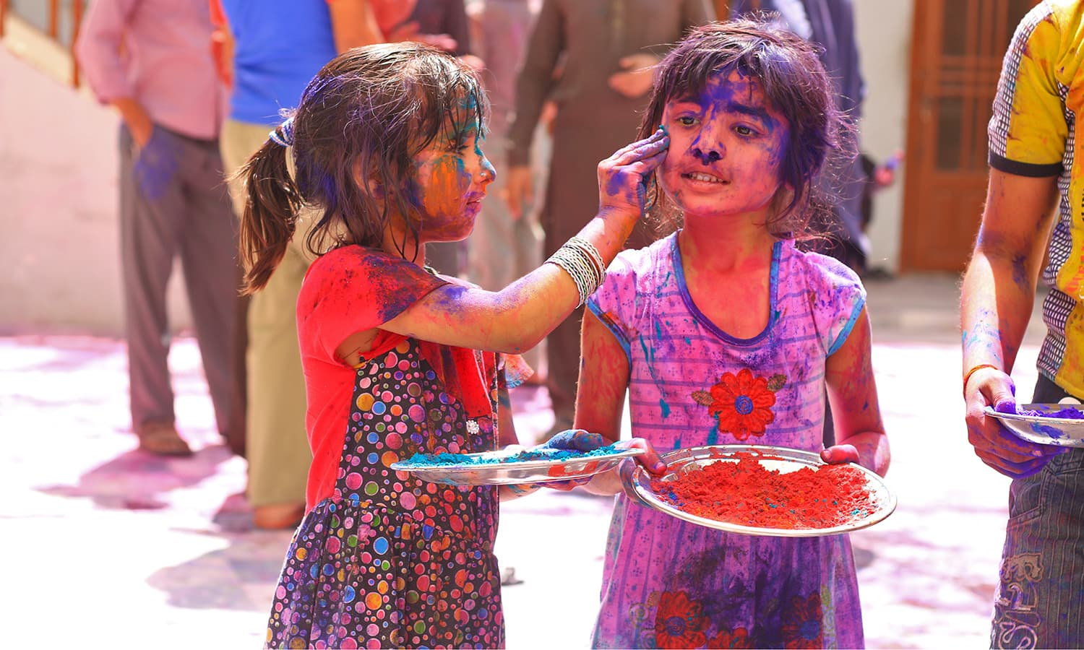

<!DOCTYPE html PUBLIC "-//W3C//DTD XHTML 1.0 Transitional//EN" "http://www.w3.org/TR/xhtml1/DTD/xhtml1-transitional.dtd">

<html xmlns="http://www.w3.org/1999/xhtml">

<head>

<meta http-equiv="Content-Type" content="text/html; charset=utf-8" />

<meta name="viewport" content="width=device-width, initial-scale=1.0">

<title> World Festivals</title>

<link href="../css/index.css" rel="stylesheet" type="text/css" />

<script src="../scripts/index.js"></script>

<link rel="stylesheet" href="https://cdnjs.cloudflare.com/ajax/libs/font-awesome/4.7.0/css/font-awesome.min.css">

</head>

<header>

<img class="logo" src="../photos/festival-1.png" width="180" height="90" />

<img class="logo2" src="../photos/Untitled-2.png" width="360" height="90" alt="FT" />

</header>

<body>

<div class="navbar">

<a href="index.html">Home</a>

<a href="News.html">News</a>

<a href="co.html">Contact Us</a>

<a href="About us.html">About</a>

<a href="#Contact us.html">Queries</a>

<a href="Gallery - Copy.html">Gallery</a>

<div class="dropdown">

<button class="dropbtn">categories

<i class="fa fa-caret-down"></i>

</button>

<div class="dropdown-content">

<a href="Africa.html">Africa</a>

<a href="Europe.html">Europe</a>

<a href="Asia.html">Asia</a>

<a href="America.html">America</a>

</div>

</div>

<div>

</div>

</div>

<div class="contact">

<h1>Queries</h1>

</div>

<h3>Send A Direct Email</h3>

<div class="container">

<form action="/action_page.php">

<label for="fname">First Name</label>

<input type="text" id="fname" name="firstname" placeholder="Your name..">

<label for="lname">Last Name</label>

<input type="text" id="lname" name="lastname" placeholder="Your last name..">

<label for="lname">Email</label>

<input type="text" id="lname" name="emailaddress" placeholder="infor@gmail.com">

<label for="continent">Continent</label>

<select id="continent" name="Continent">

<option value="Africa">Africa</option>

<option value="america">America</option>

<option value="asia">Asia</option>

<option value="europe">Europe</option>

</select>

<label for="subject">Subject</label>

<textarea id="subject" name="subject" placeholder="Write something.." style="height:200px"></textarea>

<input type="submit" value="Submit">

</form>

</div>

<div class="contact">

<h2>Please Create a new account or sign up To get more information</h2>

<button class="buttonload">

<a href="Create New Account.html">

<i class="fa fa-spinner fa-spin"></i>Create New Account

</button></a>

<button class="buttonload">

<a href="Sign up Form.html">

<i class="fa fa-circle-o-notch fa-spin"></i>Login to Current Account

</button></a>

</div>

<h2>Chat With Us</h2>

<div class="container">

<img src="../photos/Contact us Images/252371_1292941819_orig.jpg" width="100%" alt="avatar" />

<p>Hello. How are you today?</p>

<span class="time-right">11:00</span>

</div>

<div class="container darker">

<img src="../photos/Contact us Images/avatar-dribbble_1x.png" width="100%" alt="avatar" />

<p>Hey! I'm fine. Thanks for asking!</p>

<span class="time-left">11:01</span>

</div>

<div class="container">

<img src="../photos/Contact us Images/man-156584_960_720.png" width="100%" alt="avatar"/>

<p>Sweet! So, what do you wanna do today?</p>

<span class="time-right">11:02</span>

</div>

<div class="container darker">

<img src="../photos/Contact us Images/avatar-1606916_960_720.png" width="100%" alt="avatar" />

<p>Nah, I dunno. Play soccer.. or learn more coding perhaps?</p>

<span class="time-left">11:05</span>

</div>

<label for="subject">Subject</label>

<textarea id="subject" name="subject" placeholder="Write something.." style="height:200px"></textarea>

</div>

</body>

<footer>

<div class="footer1">

<center><h3>SIGN UP FOR OUR<br /> EMAIL

UPDATES</h3></center>

<center><p>Stay up to date with our whitepaper, articles<br />

and invitations to special events</p></center>

<center><a href="https://accounts.google.com/ServiceLogin/signinchooser?service=mail&passive=true&rm=false&continue=https%3A%2F%2Fmail.google.com%2Fmail%2F&ss=1&scc=1&ltmpl=default&ltmplcache=2&emr=1&osid=1&flowName=GlifWebSignIn&flowEntry=ServiceLogin">

<img src="../photos/icons/email.png" width="100" height="70" /></a></center>

</div>

<div class="footer3">

<center>

<h3>STAY CONNECTED WITH <BR />

WORLD FESTIVALS</h3>

<center><a href="https://www.facebook.com/">

<img src="../photos/icons/Facebook-HD.png" width="100" height="70" alt="facebook" />

</a>

<a href="https://plus.google.com/discover">

<img src="../photos/icons/seeicons__5783504dc2e00.png" width="100" height="70" />

</a>

<a href="https://twitter.com/?lang=en">

<img src="../photos/icons/twitter_PNG28.png" width="100" height="70" />

</a>

<a href="https://www.instagram.com/?hl=en">

<img src="../photos/icons/instagram_PNG3.png" width="100" height="70" />

</a>

<a href="https://www.youtube.com/">

<img src="../photos/icons/YouTube.png" width="100" height="70" />

</a>

</center>

</div>

<div class="footer2">

<center>

<h3>AFFILIATIONS AND<BR /> ACKNOWLEDGEMENTS</h3>

<img src="../photos/icons/Barclays-Logo.png" width="110" height="70" />

<img src="../photos/icons/500px-Emirates_logo.svg.png" width="110" height="70" />

<img src="../photos/icons/Qatar_Airways_Logo.png" width="110" height="70" /><br />

<img src="../photos/icons/USAID-Identity.svg.png" width="130" height="70" />

<img src="../photos/icons/gates-logo-bda5cc0866e8e37eccab4ac502b916c1.png" width="110" height="70" />

</div>

</center>

<center><h4> &copy; World Festivals 2017</h4></center>

</footer>

</html>

ABOUT US PAGE



<!DOCTYPE html PUBLIC "-//W3C//DTD XHTML 1.0 Transitional//EN" "http://www.w3.org/TR/xhtml1/DTD/xhtml1-transitional.dtd">

<html xmlns="http://www.w3.org/1999/xhtml">

<head>

<meta http-equiv="Content-Type" content="text/html; charset=utf-8" />

<meta name="viewport" content="width=device-width, initial-scale=1.0">

<title> About Us</title>

<link href="../css/About us.css" rel="stylesheet" type="text/css" />

<script src="../scripts/index.js" type="text/javascript"></script>

</head>

<header>

<img class="logo" src="../photos/festival-1.png" width="180" height="90" />

<img class="logo2" src="../photos/Untitled-2.png" width="360" height="90" alt="FT" />

</header>

<body>

<div class="navbar">

<a href="index.html">Home</a>

<a href="News.html">News</a>

<a href="co.html">Contact Us</a>

<a href="#About">About</a>

<a href="Contact us.html">Queries</a>

<a href="Gallery - Copy.html">Gallery</a>

<div class="dropdown">

<button class="dropbtn">categories

<i class="fa fa-caret-down"></i>

</button>

<div class="dropdown-content">

<a href="Africa.html">Africa</a>

<a href="Europe.html">Europe</a>

<a href="Asia.html">Asia</a>

<a href="America.html">America</a>

</div>

</div>

</div>

<section>

<div class="container">

<img src="../photos/work-with-us.jpg"width="1345" height="500" alt="holi" />

<div class="center">ABOUT US <BR />

</div>

</div></section>

<center>

<p>We advertise annual festivals in Asia,Africa,Europe and America.They are some of the continent with super amazing festivals celebrated by people.We also help people who are willing to attend to those festivals in those four continent.We arrange flights to our customers and book for the best lounges in those four continent where people will enjoy themselves and the services we offer to them.We offer all those with affordable prices regardless of the countries currency because we work together with banks who offer money exchange at fair rates in the whole world.</p>

</div>

</div>

<div class="team">

<h2>Meet The Team</h2>

</div>

<div class="row">

<div class="column">

<div class="card">

<img src="../photos/Contact us Images/avatar-2027365_960_720.png" width="500px" height="349px" alt="ceo" />

<div class="container">

<h2>Paul Kanyike</h2>

<p class="title">CEO & Founder</p>

<p>He founded the the company from in 2000.He is a good and hardworking man.</p>

<p>kanyikepaul@gmail.com</p>

<a href="#kanyikepl123@gmail.com"><button class="button">Contact</button></a>

</div>

</div>

</div>

<div class="row">

<div class="column">

<div class="card">

<img src="../photos/Contact us Images/oscar_boy-512.png" width="500px" height="349px" alt="manger" />

<div class="container">

<h2>Purity</h2>

<p class="title">Directing Manager</p>

<p>One of the staff has made the company stand due to her work.</p>

<p>purityl@gmail.com</p>

<a href="#purityl@gmail.com"><button class="button">Contact</button></a>

</div>

</div>

</div>

<div class="column">

<div class="card">

<img src="../photos/Contact us Images/58637085-cartoon-avatar-man-with-brown-hair-wearing-eyeglasses-front-view-over-isolated-background-vector-ill-Stock-Vector.jpg" width="500px" height="349px" alt="art director" />

<div class="container">

<h2>James Ngugi</h2>

<p class="title">Art Designer</p>

<p>The art designer has ensured that all the customers have aquired all services well.</p>

<p>jamesngugi254@gmail.com</p>

<a href="#jamesngugi254@gmail.com"><button class="button">Contact</button></a>

</div>

</div>

</div>

<div class="column">

<div class="card">

<img src="../photos/Contact us Images/avatar-1606916_960_720.png" width="500px" height="349px" alt="Head department" />

<div class="container">

<h2>Abdul Mohammud</h2>

<p class="title">Head Department</p>

<p>All the department are ensured that they have done they work well by the head department who has good coordinate.</p>

<p>abdulmohammud@gmail.com</p>

<a href="#abdulmohammud@gmail.com"><button class="button">Contact</button></a>

</div>

</div>

</div>

</div>

<h2>Get our updates</h2>

<form action="/action_page.php">

<div class="container">

<h2>Subscribe to our Newsletter</h2>

<p>We would like to inform you of our latest festivals fro the four continent and how to tour the with latest updates.Thank you.</p>

</div>

<div class="container" style="background-color:white">

<input type="text" placeholder="Name" name="name" required>

<input type="text" placeholder="Email address" name="mail" required>

<input type="checkbox" checked="checked"> Daily Newsletter

</div>

<div class="container">

<input type="submit" value="Subscribe">

</div>

</form>

</div>

</center>

</body>

<footer>

<div class="footer1">

<center><h3>SIGN UP FOR OUR<br /> EMAIL

UPDATES</h3></center>

<center><p>Stay up to date with our whitepaper, articles<br />

and invitations to special events</p></center>

<center><a href="https://accounts.google.com/ServiceLogin/signinchooser?service=mail&passive=true&rm=false&continue=https%3A%2F%2Fmail.google.com%2Fmail%2F&ss=1&scc=1&ltmpl=default&ltmplcache=2&emr=1&osid=1&flowName=GlifWebSignIn&flowEntry=ServiceLogin">

<img src="../photos/icons/email.png" width="100" height="70" /></a></center>

</div>

<div class="footer3">

<center>

<h3>STAY CONNECTED WITH <BR />

WORLD FESTIVALS</h3>

<center><a href="https://www.facebook.com/">

<img src="../photos/icons/Facebook-HD.png" width="100" height="70" alt="facebook" />

</a>

<a href="https://plus.google.com/discover">

<img src="../photos/icons/seeicons__5783504dc2e00.png" width="100" height="70" />

</a>

<a href="https://twitter.com/?lang=en">

<img src="../photos/icons/twitter_PNG28.png" width="100" height="70" />

</a>

<a href="https://www.instagram.com/?hl=en">

<img src="../photos/icons/instagram_PNG3.png" width="100" height="70" />

</a>

<a href="https://www.youtube.com/">

<img src="../photos/icons/YouTube.png" width="100" height="70" />

</a>

</center>

</div>

<div class="footer2">

<center>

<h3>AFFILIATIONS AND<BR /> ACKNOWLEDGEMENTS</h3>

<img src="../photos/icons/Barclays-Logo.png" width="110" height="70" />

<img src="../photos/icons/500px-Emirates_logo.svg.png" width="110" height="70" />

<img src="../photos/icons/Qatar_Airways_Logo.png" width="110" height="70" /><br />

<img src="../photos/icons/USAID-Identity.svg.png" width="130" height="70" />

<img src="../photos/icons/gates-logo-bda5cc0866e8e37eccab4ac502b916c1.png" width="110" height="70" />

</div>

</center>

<center><h4> &copy; World Festivals 2017</h4></center>

</footer>

</html>

## CSS CODE

HOME PAGE



@charset "utf-8";

/* CSS Document */

/* Tablet Landscape */

@media (min-device-width:600px) {

img[data-src-600px] {

content: attr(data-src-600px, url);

}

}

@media (min-device-width:800px) {

img[data-src-800px] {

content: attr(data-src-800px, url);

}

}

header {

background-color:white;

width: 100%;

height: 100px;

border: 1px ;

}

footer {

background-color: #333;

width: 100%;

height: 350px;

border: 1px;

}

.footer1 {

width:33%;

float:left;

border:1px ;

height:300px;

color:white;

}

.footer2 {

width:33%;

height:300px;

border:1px ;

float:right;

color:white;

}

.footer3 {

width:33%;

float:right;

border:1px ;

height:300px;

color:white;

}

a {

display: inline-block;

border-radius: 4px;

padding: 5px;

transition: 0.3s;

}

a:hover {

box-shadow: 0 0 2px 1px rgba(0, 140, 186, 0.5);

}

body {

background-color:#FFF;

}

.firsthomeimage {

top:0;

}

.logotext {

font-size:400%;

color:#003;

float:left;

border-left:500px;

margin-top:0;

font-weight:bold;

}

.logo{

float:left;

}

#relative {

position:relative;

width:180px;

height:90px;

text-align:left;

padding:1em;

margin:2% 20% 2% 20%;

}

#absolute {

position: absolute;

width: 30%;

height: 99.5%;

text-align: center;

top: 0;

right: 400px;

font-size: 300%;

font-family: tahoma;

}

ul {

list-style-type: none;

margin-top: 0;

padding: 0;

overflow: hidden;

background: #903;

}

li {

float: left;

}

li a {

display:block;

color:white;

text-align: center;

padding: 20px 50px;

text-decoration:none;

}

.active {

background-color:#0C0

}

li a:hover:not(.active) {

background-color:#111;

float:right;

}

.navbar {

overflow: hidden;

background-color: #333;

font-family: Arial;

}

.navbar a {

float: left;

font-size: 16px;

color: white;

text-align: center;

padding: 14px 25px;

text-decoration: none;

}

.dropdown {

float: left;

overflow: hidden;

}

.dropdown .dropbtn {

font-size: 16px;

border: none;

outline: none;

color: white;

padding: 14px 30px;

background-color: inherit;

}

.navbar a:hover, .dropdown:hover .dropbtn {

background-color: red;

}

.dropdown-content {

display: none;

position: absolute;

background-color: #f9f9f9;

min-width: 160px;

box-shadow: 0px 8px 16px 0px rgba(0,0,0,0.2);

z-index: 1;

}

.dropdown-content a {

float: none;

color: black;

padding: 12px 16px;

text-decoration: none;

display: block;

text-align: left;

}

.dropdown-content a:hover {

background-color: #ddd;

}

.dropdown:hover .dropdown-content {

display: block;

}

* {box-sizing:border-box}

body {font-family: Verdana,sans-serif;margin:0}

.mySlides {display:none}

.logo2 {

float:right;

margin-right:250px;

}

section {

width:100%;

height:500px;

border: 1px solid gray;

}

aside {

float:right;

max-width:320px;

margin:0;

padding: 1em;

max-height:20%;

}

article {

margin-right:330px;

border-right: 1px ;

padding: 1em;

overflow: hidden;

}

h1 {

text-align:center;

font-style:normal;

font-size:250%;

}

ul {

background-color:#4CAF50;

height:60px;

width:150px;

text-align:center;

color:white;

padding: 14px 16px;

display:block;

font-style:normal;

font-weight:bold;

float:right;

}

.center{

position:absolute;

top:50%;

left:50%;

transform:translate(-50%,-50%);

font-size:80px;

color:white;

}

.contact{

text-align: center;

}

.container{

position:relative;

}

.img{

opacity:0.8;

}

input[type=text], select, textarea {

width: 100%;

padding: 12px;

border: 1px solid #ccc;

border-radius: 4px;

box-sizing: border-box;

margin-top: 6px;

margin-bottom: 16px;

resize: vertical;

}

input[type=submit] {

background-color: #4CAF50;

color: white;

padding: 12px 20px;

border: none;

border-radius: 4px;

cursor: pointer;

}

input[type=submit]:hover {

background-color: #45a049;

}

.container {

border-radius: 5px;

background-color: #f2f2f2;

padding: 20px;

}

.container {

border: 2px solid #dedede;

background-color: #f1f1f1;

border-radius: 5px;

padding: 10px;

margin: 10px 0;

}

.darker {

border-color: #ccc;

background-color: #ddd;

}

.container::after {

content: "";

clear: both;

display: table;

}

.container img {

float: left;

max-width: 60px;

width: 100%;

margin-right: 20px;

border-radius: 50%;

}

.container img.right {

float: right;

margin-left: 20px;

margin-right:0;

}

.time-right {

float: right;

color: #aaa;

}

.time-left {

float: left;

color: #999;

}

NEWS PAGE



@charset "utf-8";

/* CSS Document */

/* Tablet Landscape */

@media (min-device-width:600px) {

img[data-src-600px] {

content: attr(data-src-600px, url);

}

}

@media (min-device-width:800px) {

img[data-src-800px] {

content: attr(data-src-800px, url);

}

}

header {

background-color:white;

width: 100%;

height: 100px;

border: 1px ;

}

footer {

background-color: #333;

width: 100%;

height: 350px;

border: 1px;

}

.footer1 {

width:33%;

float:left;

border:1px ;

height:300px;

color:white;

}

.footer2 {

width:33%;

height:300px;

border:1px ;

float:right;

color:white;

}

.footer3 {

width:33%;

float:right;

border:1px ;

height:300px;

color:white;

}

a {

display: inline-block;

border-radius: 4px;

padding: 5px;

transition: 0.3s;

}

a:hover {

box-shadow: 0 0 2px 1px rgba(0, 140, 186, 0.5);

}

body {

}

.firsthomeimage {

top:0;

}

.logotext {

font-size:400%;

color:#003;

float:left;

border-left:500px;

margin-top:0;

font-weight:bold;

}

.logo{

float:left;

}

#relative {

position:relative;

width:180px;

height:90px;

text-align:left;

padding:1em;

margin:2% 20% 2% 20%;

}

#absolute {

position: absolute;

width: 30%;

height: 99.5%;

text-align: center;

top: 0;

right: 400px;

font-size: 300%;

font-family: tahoma;

}

ul {

list-style-type: none;

margin-top: 0;

padding: 0;

overflow: hidden;

background: #903;

}

li {

float: left;

}

li a {

display:block;

color:white;

text-align: center;

padding: 20px 50px;

text-decoration:none;

}

.active {

background-color:#0C0

}

li a:hover:not(.active) {

background-color:#111;

float:right;

}

.navbar {

overflow: hidden;

background-color: #333;

font-family: Arial;

}

.navbar a {

float: left;

font-size: 16px;

color: white;

text-align: center;

padding: 14px 25px;

text-decoration: none;

}

.dropdown {

float: left;

overflow: hidden;

}

.dropdown .dropbtn {

font-size: 16px;

border: none;

outline: none;

color: white;

padding: 14px 30px;

background-color: inherit;

}

.navbar a:hover, .dropdown:hover .dropbtn {

background-color: red;

}

.dropdown-content {

display: none;

position: absolute;

background-color: #f9f9f9;

min-width: 160px;

box-shadow: 0px 8px 16px 0px rgba(0,0,0,0.2);

z-index: 1;

}

.dropdown-content a {

float: none;

color: black;

padding: 12px 16px;

text-decoration: none;

display: block;

text-align: left;

}

.dropdown-content a:hover {

background-color: #ddd;

}

.dropdown:hover .dropdown-content {

display: block;

}

* {box-sizing:border-box}

body {font-family: Verdana,sans-serif;margin:0}

.mySlides {display:none}

.logo2 {

float:right;

margin-right:250px;

}

section {

width:100%;

height:500px;

border: 1px ;

}

article {

border-right: 1px ;

padding: 1em;

overflow: hidden;

}

h1 {

text-align:center;

font-style:normal;

font-size:250%;

}

ul {

background-color:#4CAF50;

height:60px;

width:150px;

text-align:center;

color:white;

padding: 14px 16px;

display:block;

font-style:normal;

font-weight:bold;

float:right;

}

.center{

position:absolute;

top:50%;

left:50%;

transform:translate(-50%,-50%);

font-size:80px;

color:white;

}

.container{

position:relative;

}

.img{

opacity:0.8;

}

#myImg {

border-radius: 5px;

cursor: pointer;

transition: 0.3s;

}

#myImg:hover {opacity: 0.7;}

#myImg2 {

border-radius: 5px;

cursor: pointer;

transition: 0.3s;

}

#myImg2:hover {opacity: 0.7;}

#myImg3 {

border-radius: 5px;

cursor: pointer;

transition: 0.3s;

}

#myImg3:hover {opacity: 0.7;}

#myImg4 {

border-radius: 5px;

cursor: pointer;

transition: 0.3s;

}

#myImg4:hover {opacity: 0.7;}

#myImg5 {

border-radius: 5px;

cursor: pointer;

transition: 0.3s;

}

#myImg5:hover {opacity: 0.7;}

#myImg6 {

border-radius: 5px;

cursor: pointer;

transition: 0.3s;

}

#myImg6:hover {opacity: 0.7;}

#myImg7 {

border-radius: 5px;

cursor: pointer;

transition: 0.3s;

}

#myImg7:hover {opacity: 0.7;}

#myImg8 {

border-radius: 5px;

cursor: pointer;

transition: 0.3s;

}

#myImg8:hover {opacity: 0.7;}

#myImg9 {

border-radius: 5px;

cursor: pointer;

transition: 0.3s;

}

#myImg9:hover {opacity: 0.7;}

/* The Modal (background) */

.modal {

display: none; /* Hidden by default */

position: fixed; /* Stay in place */

z-index: 1; /* Sit on top */

padding-top: 100px; /* Location of the box */

left: 0;

top: 0;

width: 100%; /* Full width */

height: 100%; /* Full height */

overflow: auto; /* Enable scroll if needed */

background-color: rgb(0,0,0); /* Fallback color */

background-color: rgba(0,0,0,0.9); /* Black w/ opacity */

}

/* Modal Content (image) */

.modal-content {

margin: auto;

display: block;

width: 80%;

max-width: 700px;

}

/* Caption of Modal Image */

#caption {

margin: auto;

display: block;

width: 80%;

max-width: 700px;

text-align: center;

color: #ccc;

padding: 10px 0;

height: 150px;

}

/* Add Animation */

.modal-content, #caption {

-webkit-animation-name: zoom;

-webkit-animation-duration: 0.6s;

animation-name: zoom;

animation-duration: 0.6s;

}

@-webkit-keyframes zoom {

from {-webkit-transform:scale(0)}

to {-webkit-transform:scale(1)}

}

@keyframes zoom {

from {transform:scale(0)}

to {transform:scale(1)}

}

/* The Close Button */

.close {

position: absolute;

top: 15px;

right: 35px;

color: #f1f1f1;

font-size: 40px;

font-weight: bold;

transition: 0.3s;

}

.close:hover,

.close:focus {

color: #bbb;

text-decoration: none;

cursor: pointer;

}

/* 100% Image Width on Smaller Screens */

@media only screen and (max-width: 700px){

.modal-content {

width: 100%;

}

}

QUERIES PAGE



@charset "utf-8";

/* CSS Document */

/* Tablet Landscape */

@media (min-device-width:600px) {

img[data-src-600px] {

content: attr(data-src-600px, url);

}

}

@media (min-device-width:800px) {

img[data-src-800px] {

content: attr(data-src-800px, url);

}

}

header {

background-color:white;

width: 100%;

height: 100px;

border: 1px ;

}

footer {

background-color: #333;

width: 100%;

height: 350px;

border: 1px;

}

.footer1 {

width:33%;

float:left;

border:1px ;

height:300px;

color:white;

}

.footer2 {

width:33%;

height:300px;

border:1px ;

float:right;

color:white;

}

.footer3 {

width:33%;

float:right;

border:1px ;

height:300px;

color:white;

}

a {

display: inline-block;

border-radius: 4px;

padding: 5px;

transition: 0.3s;

}

a:hover {

box-shadow: 0 0 2px 1px rgba(0, 140, 186, 0.5);

}

body {

background-color:#FFF;

}

.firsthomeimage {

top:0;

}

.logotext {

font-size:400%;

color:#003;

float:left;

border-left:500px;

margin-top:0;

font-weight:bold;

}

.logo{

float:left;

}

#relative {

position:relative;

width:180px;

height:90px;

text-align:left;

padding:1em;

margin:2% 20% 2% 20%;

}

#absolute {

position: absolute;

width: 30%;

height: 99.5%;

text-align: center;

top: 0;

right: 400px;

font-size: 300%;

font-family: tahoma;

}

ul {

list-style-type: none;

margin-top: 0;

padding: 0;

overflow: hidden;

background: #903;

}

li {

float: left;

}

li a {

display:block;

color:white;

text-align: center;

padding: 20px 50px;

text-decoration:none;

}

.active {

background-color:#0C0

}

li a:hover:not(.active) {

background-color:#111;

float:right;

}

.navbar {

overflow: hidden;

background-color: #333;

font-family: Arial;

}

.navbar a {

float: left;

font-size: 16px;

color: white;

text-align: center;

padding: 14px 25px;

text-decoration: none;

}

.dropdown {

float: left;

overflow: hidden;

}

.dropdown .dropbtn {

font-size: 16px;

border: none;

outline: none;

color: white;

padding: 14px 30px;

background-color: inherit;

}

.navbar a:hover, .dropdown:hover .dropbtn {

background-color: red;

}

.dropdown-content {

display: none;

position: absolute;

background-color: #f9f9f9;

min-width: 160px;

box-shadow: 0px 8px 16px 0px rgba(0,0,0,0.2);

z-index: 1;

}

.dropdown-content a {

float: none;

color: black;

padding: 12px 16px;

text-decoration: none;

display: block;

text-align: left;

}

.dropdown-content a:hover {

background-color: #ddd;

}

.dropdown:hover .dropdown-content {

display: block;

}

* {box-sizing:border-box}

body {font-family: Verdana,sans-serif;margin:0}

.mySlides {display:none}

.logo2 {

float:right;

margin-right:250px;

}

section {

width:100%;

height:500px;

border: 1px solid gray;

}

aside {

float:right;

max-width:320px;

margin:0;

padding: 1em;

max-height:20%;

}

article {

margin-right:330px;

border-right: 1px ;

padding: 1em;

overflow: hidden;

}

h1 {

text-align:center;

font-style:normal;

font-size:250%;

}

ul {

background-color:#4CAF50;

height:60px;

width:150px;

text-align:center;

color:white;

padding: 14px 16px;

display:block;

font-style:normal;

font-weight:bold;

float:right;

}

.center{

position:absolute;

top:50%;

left:50%;

transform:translate(-50%,-50%);

font-size:80px;

color:white;

}

.contact{

text-align: center;

}

.container{

position:relative;

}

.img{

opacity:0.8;

}

input[type=text], select, textarea {

width: 100%;

padding: 12px;

border: 1px solid #ccc;

border-radius: 4px;

box-sizing: border-box;

margin-top: 6px;

margin-bottom: 16px;

resize: vertical;

}

input[type=submit] {

background-color: #4CAF50;

color: white;

padding: 12px 20px;

border: none;

border-radius: 4px;

cursor: pointer;

}

input[type=submit]:hover {

background-color: #45a049;

}

.container {

border-radius: 5px;

background-color: #f2f2f2;

padding: 20px;

}

.container {

border: 2px solid #dedede;

background-color: #f1f1f1;

border-radius: 5px;

padding: 10px;

margin: 10px 0;

}

.darker {

border-color: #ccc;

background-color: #ddd;

}

.container::after {

content: "";

clear: both;

display: table;

}

.container img {

float: left;

max-width: 60px;

width: 100%;

margin-right: 20px;

border-radius: 50%;

}

.container img.right {

float: right;

margin-left: 20px;

margin-right:0;

}

.time-right {

float: right;

color: #aaa;

}

.time-left {

float: left;

color: #999;

}

ABOUT US PAGE



@charset "utf-8";

/* CSS Document */

/* Tablet Landscape */

@media (min-device-width:600px) {

img[data-src-600px] {

content: attr(data-src-600px, url);

}

}

@media (min-device-width:800px) {

img[data-src-800px] {

content: attr(data-src-800px, url);

}

}

header {

background-color:white;

width: 100%;

height: 100px;

border: 1px ;

}

footer {

background-color: #333;

width: 100%;

height: 350px;

border: 1px;

}

.footer1 {

width:33%;

float:left;

border:1px ;

height:300px;

color:white;

}

.footer2 {

width:33%;

height:300px;

border:1px ;

float:right;

color:white;

}

.footer3 {

width:33%;

float:right;

border:1px ;

height:300px;

color:white;

}

a {

display: inline-block;

border-radius: 4px;

padding: 5px;

transition: 0.3s;

}

a:hover {

box-shadow: 0 0 2px 1px rgba(0, 140, 186, 0.5);

}

body {

background-color:#3D9970;

}

.firsthomeimage {

top:0;

}

.logotext {

font-size:400%;

color:#003;

float:left;

border-left:500px;

margin-top:0;

font-weight:bold;

}

.logo{

float:left;

}

#relative {

position:relative;

width:180px;

height:90px;

text-align:left;

padding:1em;

margin:2% 20% 2% 20%;

}

#absolute {

position: absolute;

width: 30%;

height: 99.5%;

text-align: center;

top: 0;

right: 400px;

font-size: 300%;

font-family: tahoma;

}

ul {

list-style-type: none;

margin-top: 0;

padding: 0;

overflow: hidden;

background: #903;

}

li {

float: left;

}

li a {

display:block;

color:white;

text-align: center;

padding: 20px 50px;

text-decoration:none;

}

.active {

background-color:#0C0

}

li a:hover:not(.active) {

background-color:#111;

float:right;

}

.navbar {

overflow: hidden;

background-color: #333;

font-family: Arial;

}

.navbar a {

float: left;

font-size: 16px;

color: white;

text-align: center;

padding: 14px 25px;

text-decoration: none;

}

.dropdown {

float: left;

overflow: hidden;

}

.dropdown .dropbtn {

font-size: 16px;

border: none;

outline: none;

color: white;

padding: 14px 30px;

background-color: inherit;

}

.navbar a:hover, .dropdown:hover .dropbtn {

background-color: red;

}

.dropdown-content {

display: none;

position: absolute;

background-color: #f9f9f9;

min-width: 160px;

box-shadow: 0px 8px 16px 0px rgba(0,0,0,0.2);

z-index: 1;

}

.dropdown-content a {

float: none;

color: black;

padding: 12px 16px;

text-decoration: none;

display: block;

text-align: left;

}

.dropdown-content a:hover {

background-color: #ddd;

}

.dropdown:hover .dropdown-content {

display: block;

}

* {box-sizing:border-box}

body {font-family: Verdana,sans-serif;margin:0}

.mySlides {display:none}

.logo2 {

float:right;

margin-right:250px;

}

section {

width:100%;

height:500px;

border: 1px ;

}

article {

border-right: 1px ;

padding: 1em;

overflow: hidden;

}

h1 {

text-align:center;

font-style:normal;

font-size:250%;

}

ul {

background-color:#4CAF50;

height:60px;

width:150px;

text-align:center;

color:white;

padding: 14px 16px;

display:block;

font-style:normal;

font-weight:bold;

float:right;

}

.center{

position:absolute;

top:50%;

left:50%;

transform:translate(-50%,-50%);

font-size:80px;

color:white;

}

.container{

position:relative;

}

.img{

opacity:0.8;

}

#myImg {

border-radius: 5px;

cursor: pointer;

transition: 0.3s;

}

#myImg:hover {opacity: 0.7;}

#myImg2 {

border-radius: 5px;

cursor: pointer;

transition: 0.3s;

}

#myImg2:hover {opacity: 0.7;}

#myImg3 {

border-radius: 5px;

cursor: pointer;

transition: 0.3s;

}

#myImg3:hover {opacity: 0.7;}

#myImg4 {

border-radius: 5px;

cursor: pointer;

transition: 0.3s;

}

#myImg4:hover {opacity: 0.7;}

#myImg5 {

border-radius: 5px;

cursor: pointer;

transition: 0.3s;

}

#myImg5:hover {opacity: 0.7;}

#myImg6 {

border-radius: 5px;

cursor: pointer;

transition: 0.3s;

}

#myImg6:hover {opacity: 0.7;}

#myImg7 {

border-radius: 5px;

cursor: pointer;

transition: 0.3s;

}

#myImg7:hover {opacity: 0.7;}

#myImg8 {

border-radius: 5px;

cursor: pointer;

transition: 0.3s;

}

#myImg8:hover {opacity: 0.7;}

#myImg9 {

border-radius: 5px;

cursor: pointer;

transition: 0.3s;

}

#myImg9:hover {opacity: 0.7;}

/* The Modal (background) */

.modal {

display: none; /* Hidden by default */

position: fixed; /* Stay in place */

z-index: 1; /* Sit on top */

padding-top: 100px; /* Location of the box */

left: 0;

top: 0;

width: 100%; /* Full width */

height: 100%; /* Full height */

overflow: auto; /* Enable scroll if needed */

background-color: rgb(0,0,0); /* Fallback color */

background-color: rgba(0,0,0,0.9); /* Black w/ opacity */

}

/* Modal Content (image) */

.modal-content {

margin: auto;

display: block;

width: 80%;

max-width: 700px;

}

/* Caption of Modal Image */

#caption {

margin: auto;

display: block;

width: 80%;

max-width: 700px;

text-align: center;

color: #ccc;

padding: 10px 0;

height: 150px;

}

/* Add Animation */

.modal-content, #caption {

-webkit-animation-name: zoom;

-webkit-animation-duration: 0.6s;

animation-name: zoom;

animation-duration: 0.6s;

}

@-webkit-keyframes zoom {

from {-webkit-transform:scale(0)}

to {-webkit-transform:scale(1)}

}

@keyframes zoom {

from {transform:scale(0)}

to {transform:scale(1)}

}

/* The Close Button */

.close {

position: absolute;

top: 15px;

right: 35px;

color: #f1f1f1;

font-size: 40px;

font-weight: bold;

transition: 0.3s;

}

.close:hover,

.close:focus {

color: #bbb;

text-decoration: none;

cursor: pointer;

}

/* 100% Image Width on Smaller Screens */

@media only screen and (max-width: 700px){

.modal-content {

width: 100%;

}

}